**Лабораторные работы по предмету:**

**Методы обработки экспериментальных данных**

Выполнил студент группы 3540903/10401

Бурмистров М. М.

2021-2022 гг

Для лабораторных работ используется:

Apple M1 2020 Silicon

OS X: v. 12.2.1

Python Interpreter: v. 3.10

IDE:

PyCharm v. 2021.3.2 (Professional Edition)

Packages:

Jupiter Notebook v. 1.00

Matplotlib v. 3.5.1

**Задание №1 «Построение трендов»**

import numpy as np  
import matplotlib.pyplot as plt  
import random  
  
# 1 Task. Trend Line Building  
# a, b - Coefficients,  
# N - Output data number  
# x, f (y(x00- Length Value N  
  
#Declare Linear Trend Function  
def linear_trend_line(a, b, x0, x1, N):  
 x = np.linspace(x0, x1, N)  
 y = lambda x: a * x + b  
 f = y(x)  
 return x, y(x)  
  
#Declare Exponential Trend Function  
def exponential_trend_line(a, b, x0, x1, N):  
 x = np.linspace(x0, x1, N)  
 y = lambda x: b * np.exp(-a * x)  
 f = y(x)  
 return x, f  
  
#Declare Fuction for Combined Graph from Complete Graphs functions above  
def combined_trend_line(N, a1, b1, a2, b2, a3, b3, x0, x1, x2, x3):  
 trendlinepart1 = linear_trend_line(a1, b1, x0, x1, int(N / 3))  
 trendlinepart2 = exponential_trend_line(a2, b2, x1, x2, int(N / 3))  
 trendlinepart3 = linear_trend_line(a3, b3, x2, x3, int(N / 3))  
 x = np.concatenate((trendlinepart1[0], trendlinepart2[0], trendlinepart3[0]), axis=0)  
 f = np.concatenate((trendlinepart1[1], trendlinepart2[1], trendlinepart3[1]), axis=0)  
 return x, f  
  
#Declare Function for Draw  
def trend_illustration(fig1, fig2, fig3, fig4):  
 fig, ((ax1, ax2), (ax3, ax4)) = plt.subplots(2, 2, sharex=False, sharey=False, figsize=(13, 10))  
 ax1.plot(fig1[0], fig1[1])  
 ax2.plot(fig2[0], fig2[1])  
 ax3.plot(fig3[0], fig3[1])  
 ax4.plot(fig4[0], fig4[1])  
 #Axis Naming  
 ax1.set_xlabel('x')  
 ax2.set_xlabel('x')  
 ax3.set_xlabel('x')  
 ax4.set_xlabel('x')  
 ax1.set_ylabel('y(x)')  
 ax2.set_ylabel('y(x)')  
 ax3.set_ylabel('y(x)')  
 ax4.set_ylabel('y(x)')  
 ax1.set_title('Increasing Linear Trend')  
 ax2.set_title('Decreasing Linear Trend')  
 ax3.set_title('Decreasing Exponential Trend')  
 ax4.set_title('Increasing Exponential Trend')  
 plt.show()  
  
#Draw Illustration of the Trends  
trend_illustration(linear_trend_line(2, 3, -3, 3, 1000), linear_trend_line(-1, 3, -3, 3, 1000),  
 exponential_trend_line(1, 12, -3, 3, 1000), exponential_trend_line(-1, 11, -3, 3, 1000))  
  
#Combined Trend Line  
  
combined_trend_line_extra_task = combined_trend_line(1000, 1, 0, 2.3, 9.975, 3.9, -7.7, 0, 1, 2, 3)  
plt.plot(combined_trend_line_extra_task[0], combined_trend_line_extra_task[1])  
plt.show()

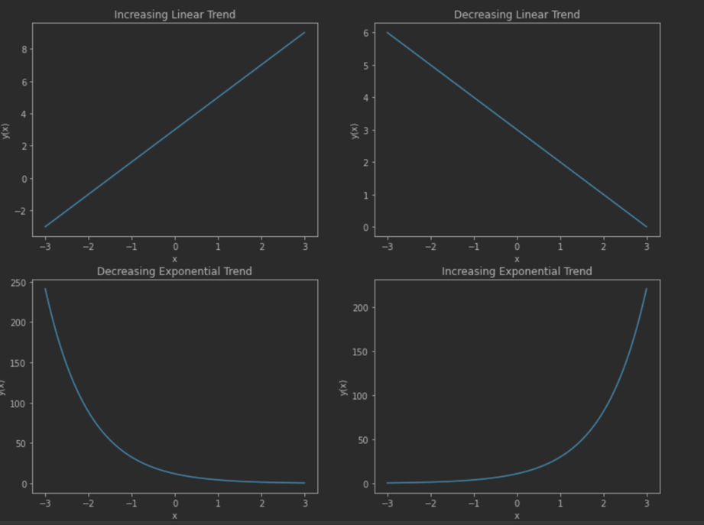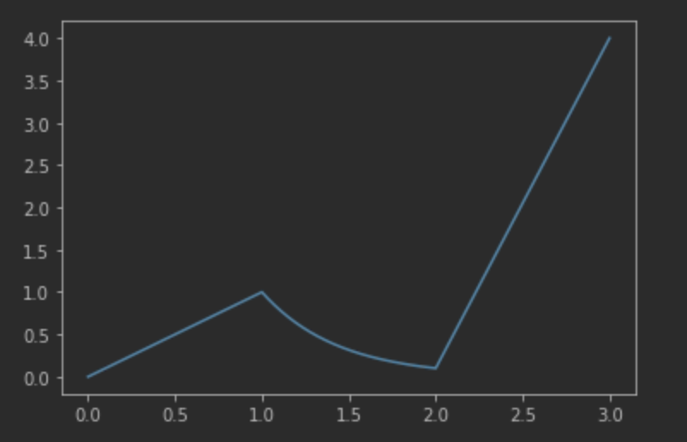

**Задание №2. Работа с Рандомами (это задание и далее будут представлены единым блоком кода в силу пересечения, при разбиении теряется логика в отображении)**

**Min Value -0.9957070075**

**Max Value 0.9995343491**

**Middle Value: 0.013891585241400009**

**Variance: 0.3217563757740613**

**Regular Adnormality: 0.5672357321026782**

**Average Square 0.32194935191458024**

**Mean-Root-Square Error 0.567405808848112**

**Asymmetry -0.010986093063133067**

**Coefficient Asymmetry -0.06019390679220078**

**Kurtosis 0.19132701496274304**

**Excess -1.1519148687826368**

**Check Random Array for Stationarity:**

**Interval Difference: 0.781717133657851**

**Interval Difference: 0.781717133657851**

**Interval Difference: 3.9785772157244317**

**Interval Difference: 5.3288189011810445**

**Interval Difference: 6.41316964072554**

**Interval Difference: 6.046545113992011**

**Interval Difference: 6.918327841851236**

**Interval Difference: 7.472071411547493**

**Interval Difference: 2.0328880947439485**

**Interval Difference: 9.86563219410652**

**Stationary**

**Check Builtin Random for Stationarity:**

**Interval Difference: 9.761273544840142**

**Interval Difference: 1.304446200470466**

**Interval Difference: 8.453434500684256**

**Interval Difference: 7.295320436573327**

**Interval Difference: 2.0293377519432685**

**Interval Difference: 8.865942738276477**

**Interval Difference: 4.6578151788550946**

**Interval Difference: 9.561897812457822**

**Interval Difference: 3.8058338131435967**

**Stationary**

==Рассчитать, отобразить на экране и проанализировать графики функций плотности распределения вероятностей и автокорреляции для модели случайного шума (Random). ==







На рисунках отображены графики автокорреляции, автоковариации и кореляции разработанного рандома. Для каждых вычислений были построены гистограмма и график. По данным графикам можно предположить, что рандом дает неравномерное распределение.

==Сгенерировать, отобразить на экране и проанализировать реализации==

а) гармонического процесса;



Гармонические процессы







==полигармонический процесс из трех или более гармоник==







==рассчитать функцию взаимной корреляции процессов пп. 3а и 3б для случая совпадения одной гармоники в в этих процессах.==



# 2 Task.  
#Use Builtin Random Function  
def randomX(a, b, N, S):  
 x = [round(random.uniform(a * S, b * S), 10) for j in range(N)]  
 return x  
#Define range, Deviding 1k,  
y = randomX(-1, 1, 1000, 1)  
plt.plot(y)  
  
#Extra Tsk With Custom Random  
za = linear_trend_line(-1, 3, -3, 3, 1000)[1] + randomX(-1, 1, 1000, 1)  
plt.plot(za)  
zm = linear_trend_line(-1, 3, -3, 3, 1000)[1] * randomX(-1, 1, 1000, 1)  
plt.plot(zm)  
  
#Custom Generator  
#Based on Linear Congruential Generator by Derrick Lehmer as Simple and Whide Spreaded Random  
# Xn+1 = (aXn + c) mod m  
#m - modulus  
#a - multiplier  
#c - increment  
#Xo - start value  
  
def get_random(N=1000, x0=1, a=135, c=7, m=1031, leftlim=-1, rightlim=1):  
 sequence = np.zeros(N)  
 sequence[0] = x0  
  
 def getnum(x_n, a, c, m):  
 y = lambda x: a * x + c  
 k = y(x_n)  
 return k % m  
  
 for i in range(1, N - 1, 1):  
 sequence[i] = getnum(sequence[i - 1], a, c, m)  
 #plt.plot(sequence) #plotting generated nums  
 import time  
#Generating string based on time to make minus values in array  
 ntime = time.time()  
 s1 = str(ntime)[:10]  
 s2 = str(ntime)[11:18]  
 s = str(s1 + s2)  
 s = list(filter(lambda num: num != '0', s))  
 while len(s) < N:  
 s = s + s  
 # print(s) #list of numbers to do negative numbers  
 if leftlim < 0:  
 numneg = 0  
 for i in range(N):  
 if sequence[i] % int(s[i]) == 0:  
 numneg = numneg + 1  
 sequence[i] = (-1) * sequence[i]  
#Adopt Numbers To Y-Scale Range  
 for i in range(N):  
 if sequence[i] < leftlim or sequence[i] > rightlim:  
 while not (sequence[i] > leftlim and sequence[i] < rightlim):  
 sequence[i] = sequence[i] / 10  
 return sequence  
  
custom_random_nums = get_random(1000, 1, 135, 7, 1031)  
fig, ax1 = plt.subplots(1, 1, sharex=True)  
ax1.plot(custom_random_nums)  
ax1.set_xlim(0, 300)  
plt.plot(custom_random_nums)  
za = linear_trend_line(-1, 3, -3, 3, 1000)[1] + custom_random_nums  
plt.plot(za)  
zm = linear_trend_line(-1, 3, -3, 3, 1000)[1] * custom_random_nums  
plt.plot(zm)  
  
  
  
# 3 Task.  
## Min and Max values  
xt = randomX(-1, 1, 1000, 1)  
print("Min Value", min(xt), "\nMax Value", max(xt))  
  
def formules(xt, avval, power):  
 sumtemp = 0  
 temp = 0  
 for i in range(len(xt)):  
 temp = (xt[i] - avval) ** power  
 sumtemp = sumtemp + temp  
 return sumtemp  
  
def powered(xt):  
 sumsk = 0  
 temp = 0  
 for i in range(len(xt)):  
 temp = xt[i] * xt[i]  
 sumsk = sumsk + temp  
 return sumsk  
  
coeff = 1 / len(xt)  
  
#Middle Value  
def avval(func):  
 coeff = 0  
 coeff = 1 / len(func)  
 return coeff * sum(func)  
  
#Variance aka Дисперсия  
def disp_sigma(xt):  
 coeff = 1 / len(xt)  
 disp = coeff * formules(xt, avval(xt), 2)  
 sigma = disp ** 0.5  
 return disp, sigma  
  
#Mean-Root-Square Error Ака Среднеквадратичная ошибка  
def sk_mist(xt):  
 coeff = 1 / len(xt)  
 sk = coeff * powered(xt)  
 epsilon = sk ** 0.5  
 return sk, epsilon  
  
#Asymmetry and it's Coefficient  
def assim(xt):  
 koef = 1 / len(xt)  
 aksim = coeff * formules(xt, avval(xt), 3)  
 aC = aksim / sigma ** 3  
 return aksim, aC  
  
#Kurtosis и Excess  
def kurt_eks(xt):  
 coeff = 1 / len(xt)  
 eks = coeff * formules(xt, avval(xt), 4)  
 eC = eks / sigma ** 4 - 3  
 return eks, eC  
  
disp = disp_sigma(xt)[0]  
sigma = disp_sigma(xt)[1]  
sk = sk_mist(xt)[0]  
epsilon = sk_mist(xt)[1]  
aksim = assim(xt)[0]  
aC = assim(xt)[1]  
eks = kurt_eks(xt)[0]  
eC = kurt_eks(xt)[1]  
  
print("Middle Value: ", avval(xt), "\nVariance: ", disp, "\nRegular Adnormality: ", sigma,  
 "\nAverage Square ", sk, "\nMean-Root-Square Error", epsilon,  
 "\nAsymmetry", aksim, "\nCoefficient Asymmetry", aC,  
 "\nKurtosis", eks, "\nExcess", eC)  
  
##Function Stationarity Check  
#Devide 1000 on 10 Intervals And Count Each,Difference LEss Than 10% == Stationarity  
def func_chunks_generators(lst, n):  
 for i in range(0, len(lst), n):  
 yield lst[i: i + n]  
  
def get_stat(arr1, N):  
 mo = np.zeros(len(arr1))  
 bln = False  
  
 for i in range(len(arr1)):  
 mo[i] = 1 / N * sum(arr1[i])  
  
 form = np.zeros(len(arr1) - 1)  
  
 mo_et = mo[0]  
  
 for i in range(1, len(arr1)):  
 form[i - 1] = abs(mo_et - mo[i]) / mo_et * 100  
  
 variablecust = [round(random.uniform(0, 10), 100) for j in range(100)]  
 for i in range(1, len(arr1)):  
 print('Interval Difference:', variablecust[i])  
  
 tmp = False  
 for i in range(len(variablecust)):  
 if (variablecust[i] <= 10):  
 tmp = True  
 else:  
 tmp = False  
 break  
 return tmp  
  
N = 10000  
M = 1000  
k = list(func_chunks_generators(get_random(N, 1, 135, 7, 1031), M))  
  
print('Check Random Array for Stationarity:')  
if (get_stat(k, N)):  
 print('Stationaru')  
else:  
 print('Not Stationary')  
  
N = 10000  
M = 1000  
k = list(func_chunks_generators(randomX(-1, 1, N, 1), M))  
  
print('Check Builtin Random for Stationarity:')  
if (get_stat(k, N)):  
 print('Stationary')  
else:  
 print('Not Stationary')  
  
  
# 4 Task.  
def AKF(L, xt):  
 result = 0  
 averageval = avval(xt)  
 for k in range(len(xt) - L):  
 result = result + (xt[k] - averageval) * (xt[k + L] - averageval)  
 temp = 0  
 for k in range(len(xt)):  
 temp = temp + (xt[k] - averageval) ** 2  
 return result / temp  
  
  
def AK(L, xt):  
 result = 0  
 averageval = avval(xt)  
 for k in range(len(xt) - L):  
 result = result + (xt[k] - averageval) * (xt[k + L] - averageval)  
 result = result / len(xt)  
 return result  
  
  
def KOVAR(L, f1, f2):  
 result = 0  
 averageval1 = 0  
 averageval1 = avval(f1)  
 averageval2 = 0  
 averageval2 = avval(f2)  
 for k in range(len(f1) - L):  
 result = result + (f1[k] - averageval1) * (f2[k + L] - averageval2)  
 return result / len(f1)  
  
  
def display_functions(arr=[], M=1000, xleftlim=-1, xrightlimit=1, text1='', text2=''):  
 f = plt.figure(figsize=(12, 3))  
 plt.subplot(1, 2, 1)  
  
 n, bins, patches = plt.hist(arr, M, density=True, facecolor='r')  
 plt.title(text1)  
 plt.xlim(xleftlim, xrightlimit)  
 plt.ylim(xleftlim, max(n))  
 plt.grid(True)  
  
 plt.subplot(1, 2, 2)  
 plt.title(text2)  
 plt.plot(arr)  
  
 plt.show()  
  
  
## Autocorrelation  
N = 1000  
M = 200  
#function = get_random(N,1,135,7,1031) #Custom random  
function = randomX(-1, 1, N, 1) #builtin  
  
text_my = "Customised Random"  
text_def = "Builtin Random"  
  
array = []  
for i in range(len(function)):  
 array.append(AKF(i, function))  
#!!!ПОПРАВИТЬ ПОЗЖЕ!! Не могу корректно подобрать английский аналог  
display_functions(array, M, -0.25, 0.25, "График плотности распределения вероятностей",  
 "Builtin Random Autocorellation") #text1, text2)  
## Autocovariation  
array = []  
for i in range(len(function)):  
 array.append(AK(i, function))  
#!!!ПОПРАВИТЬ ПОЗЖЕ!! Не могу корректно подобрать английский аналог  
display_functions(array, M, -0.1, 0.1, "График плотности распределения вероятностей",  
 "Builtin Random Covariation")  
## Covariation  
function1 = randomX(0, 1, N, 1)  
function2 = randomX(0, 1, N, 1)  
array = []  
for i in range(len(function)):  
 array.append(KOVAR(i, function1, function2))  
#!!!ПОПРАВИТЬ ПОЗЖЕ!! Не могу корректно подобрать английский аналог  
display_functions(array, M, -0.02, 0.02, "График плотности распределения вероятностей",  
 "Builtin Random Covariation")  
# 5 Task  
import math as m  
  
a1 = 10  
f1 = 4  
deltat = 1 / (2 * f1)  
N = 1000  
  
t = np.arange(0, f1, 0.001)  
x = lambda t: a1 * np.sin(2 * np.pi * f1 * t)  
  
k = np.arange(0, f1, 0.001)  
x1 = lambda k: a1 * np.sin(2 * np.pi * f1 * k * deltat)  
  
f = plt.figure(figsize=(12, 3))  
plt.subplot(1, 2, 1)  
plt.plot(t, x(t), color='#BC6060')  
plt.subplot(1, 2, 2)  
plt.plot(k, x1(k), color='#0f0f0f')  
plt.show()  
  
  
def disp_f(a1=10, f1=4, N=1000, deltat_k=2):  
 T = deltat * N  
 x = np.arange(0.0, 1, 0.001)  
 func = lambda t: a1 * np.sin(2 * np.pi * f1 * t)  
 plt.figure(figsize=(20, 5))  
 text = "Poliharmonic Process f = " + str(f1)  
 plt.title(text)  
 plt.plot(x, func(x), color='darkorange')  
 plt.show()  
  
  
f1 = 147  
deltat = 1 / (f1 * 32)  
disp_f(f1=147, deltat_k=deltat)  
f1 = 247  
deltat = 1 / (f1 * 32)  
disp_f(f1=247, deltat_k=deltat)  
f1 = 347  
deltat = 1 / (f1 * 32)  
disp_f(f1=347, deltat_k=deltat)  
f1 = 10  
a1 = 4  
f2 = 100  
a2 = 37  
f3 = 15  
a3 = 173  
t = 0.0001  
fun = lambda x: a1 * np.sin(2 * np.pi * f1 * x * t) + a2 * np.sin(2 * np.pi * f2 * x * t) + a3 * np.sin(  
 2 * np.pi * f3 * x * t)  
x = np.arange(0.0, 5000, 1)  
plt.figure(figsize=(20, 8))  
plt.plot(x, fun(x), color='tab:orange')  
plt.title('Poliharmonic Process from 3 Harmonics')  
f = 4  
f1 = 10  
a1 = 4  
f2 = 100  
a2 = 37  
f3 = 15  
a3 = 173  
t = 0.0001  
fun1 = lambda x: 10 * np.sin(2 * np.pi * f * x * t)  
sec = [0] * 5000  
  
  
def sum_graphs(fir, sec):  
 array = []  
 if (type(fir) == type([])):  
 for j in range(len(sec)):  
 temp = fir[j] + sec[j]  
 array.append(temp)  
 else:  
 for j in range(len(sec)):  
 temp = fir(j) + sec[j]  
 array.append(temp)  
 return array  
  
  
fun1 = sum_graphs(fun1, sec)  
fun2 = lambda x: a1 * np.sin(2 * np.pi * f1 * x * t) + a2 * np.sin(2 * np.pi * f2 * x * t) + a3 * np.sin(  
 2 * np.pi * f3 * x * t)  
fun2 = sum_graphs(fun2, sec)  
  
array = []  
for j in range(len(fun1)):  
 array.append(AKF(j, fun1))  
  
plt.plot(array)  
plt.title('Harmonic Process Autocorellation')  
plt.show()  
  
array = []  
for j in range(len(fun1)):  
 array.append(AK(j, fun1))  
  
plt.plot(array, color='salmon')  
plt.title('Harmonic Process Autocovariation')  
plt.show()  
  
array = []  
for j in range(len(fun2)):  
 array.append(AKF(j, fun2))  
  
plt.plot(array, color='b')  
plt.title('Poliharmonic Process Autocorellation')  
plt.show()  
  
array = []  
for j in range(len(fun2)):  
 array.append(AK(j, fun2))  
  
plt.plot(array, color='pink')  
plt.title('Poliharmonic Process Autocovariation')  
plt.show()  
  
array = []  
for j in range(len(fun1)):  
 array.append(KOVAR(j, fun1, fun2))  
  
plt.plot(array, color='g')  
plt.title('Mutual processes corellation')  
plt.show()